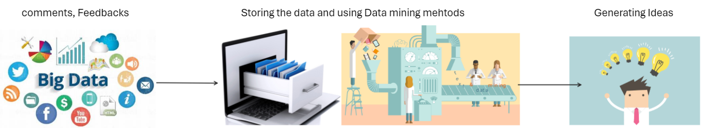

|  |  |
| --- | --- |
| A picture of a winding road and trees  TECHNICAL REPORT  Orange Jordan | A close-up of a logo  Description automatically generated  Overview  This is a technical document for a Project ‘Your Feedback, Our Future’ that I am designing for orange Jordan. This project aims to explore the ability to add a big data system using advanced data mining technology. This system turns the comments and feedback from multiple sources into ideas that would help in maintaining continuous advance for products and services at orange Jordan.  Student name: YOUSEF ABU ALI (21110294)  Instructor name: Rami Ibrahim |

1. Introduction:

* The concept of big data has become more common lately. The name big data represents the huge amount of new data that is being generated including its complexity and size all over the world. One of the examples of big data is the data generated from social media platforms. Also, big data is known for its three main characteristics: volume, velocity, and variety.
* Big data with its difficult characteristics requires very powerful technology and methods in order to help with its analysis. In addition, managing such kinds of datasets requires big storage, strong tools for analysis, and advanced infrastructure.
* In order to successfully handle these kinds of data, requires the use of smart approaches by making sure we focus on quality, security, and ethical practices for such information.

The following are some examples of the applications of big data, and they are also related to my idea which is a data generating system:

1. The global technology report of Cisco:

This report discusses the importance of big data, and it shows how businesses are currently prioritizing big data in their every day-to-day life in order to improve their operations. The report also discussed that two out of three IT managers consider big data as a main point in the future.

1. Case study on Cisco data intelligence platform(CDIP):

This case study discusses the current problems when managing huge amounts of data (big data), and it shows the CDIP as an example to help in that. It says that CDIP is an important tool for the fields of data mining that would help in managing big data.

1. An article that discusses the collaboration between Cisco and Cloudera:

This article discusses the collaboration between Cisco and Cloudera that was meant to enhance the process of dealing with big data and the way of storing such data. It also discusses the evolution of tools such as Hadoop and it also introduced Apache ozone. It discusses the importance of using such tools to be a solution for storing huge amounts of data.

1. An article that discusses the evolution of data:

This article discussed the challenges that IT managers face when they are dealing with huge amounts of data. And it suggested using hybrid solutions such as cloud-based approaches. It also showed the importance of using data mining methods to use in data generation.

1. An article that shows Cisco solution for analytics and big data:

This article mainly focused on the methods that Cisco addressed related to the challenges of big data. It mainly focused on scalability, security for Data, and cost required for such operations.

* The impact of big data and the applications of this technology has proven its great effectiveness through many sectors by improving the operational efficiency for them. Big data is being used by companies to understand their customer behavior, for improve the health care process in a hospital, as well as helping in reducing energy bills. It also helps telecommunication companies to track what people do through their day, such as things they searched for or their purchases, which would help them in marketing. (Yale Insights, 2016)
* In the healthcare sector big data provides real time analysis that would help in building models to protect patient’s outcome and optimize treatment plans and overall patients’ health. (Precisely, 2021)
* In finance, big data is important when detecting fraud transactions and risk management through providing real time analysis for the data in order to maintain security measures. (Precisely, 2021)
* In manufacturing big data has played an important role in improving production by minimizing downtime, reducing cost for operation, as well as improving productivity. (Precisely, 2021)
* In retail big data is important to analyze and understand customer behavior in order to provide personalized marketing as well as enhancing the overall shopping experience to increase customer satisfaction and revenue. (Precisely, 2021)
* And as mentioned before Hadoop and Apache ozone or some of the tools used by big companies such as Cisco and Cloudera in order to enhance the process of storing big data.

1. Recommendations:
   1. Analysis for the survey:

This pie chart shows that 58.3% of the employees that answered this survey were identified as male, and 41.7% were identified as females. Which show diversity and genders which would result in different range of skills and strength within the team

* Q1:

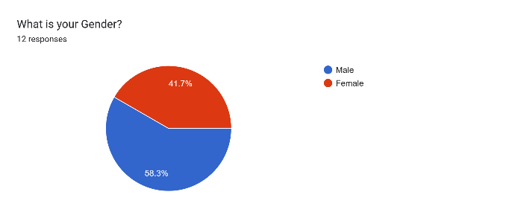

* Q2

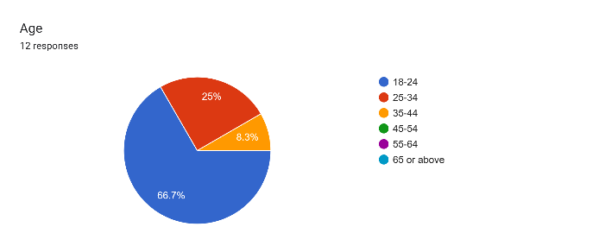

This pie chart shows that 75% of orange IT team that answered the survey were young, with an age between (18-44). Which means that these employees would have better energy and strong technology skills.

* Q3

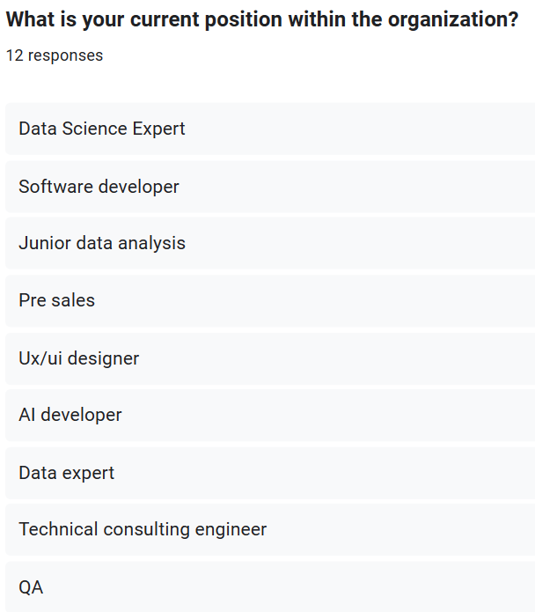

From the responses of this question, I figured that orange IT team has a wide range of experts, with positions such as data science expert, software developer, junior data analysis, presales, designers, AI developers, data experts, etc. Which would mean there would be better problem solving and higher efficiency while working on the project.

* Q4

This pie chart shows that 41.7% of the employees has good knowledge of big data, 25% have some knowledge, and 33.3% are new to it. I think that training employees could help in having better knowledge of big data considering that it's very important.

Forms response chart. Question title: How familiar are you with the concept of big data?
. Number of responses: 12 responses.

* Q5

This pie chart shows that 91.7% of the employees have encountered or used big data, which suggests that people have good awareness or a little bit of knowledge on big data.

Forms response chart. Question title: Have you encountered or used big data technologies in your personal or professional life?
. Number of responses: 12 responses.

* Q6

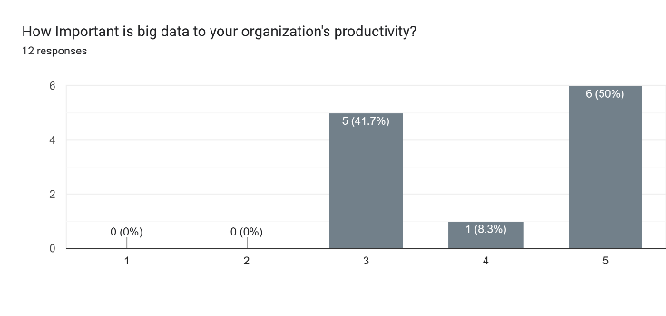

This chart shows that most of the employees believe that big data is important for their productivity and 41.7% are neutral. Which indicate that such project would be viable, and this company and people will be eager to work on it.

* Q7

This bar chart shows the collection methods of customer feedback. With social media being the top feedback collecting method followed by customer service interaction, in store feedback and online surveys. Therefore, we should focus more on social media to have better results.

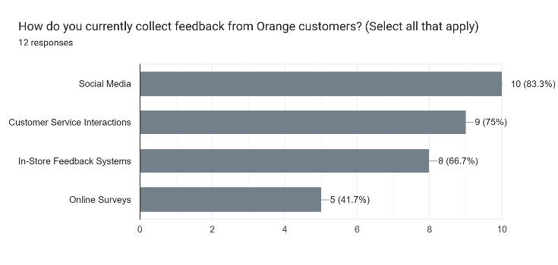

* Q8

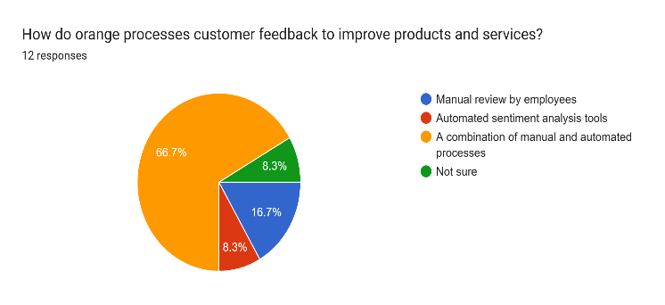

This question was meant to understand the current customer feedback processing method and most of the employees who conducted the survey said that it's a combination of manual and automated process. Which means there would be a good understanding of the system suggested.

* Q9

This question was meant to understand the most valuable type of feedback that would help in generating good ideas, and it showed that negative feedback are the most important ones. Which indicates that the system should focus on negative feedback to generate better ideas.

Forms response chart. Question title: When it comes to gathering customer feedback, which types of feedback do you think are most valuable for generating innovative ideas? (Select all that apply)
. Number of responses: 12 responses.

* Q10

This question was meant to understand the features that the employees of orange would prefer to have in the system. the most agreed on feature was visual representation of Data insights followed by the other three features in a similar percentage. Therefore, we should incorporate all of these features to have better user engagement.

Forms response chart. Question title: What features would you consider important for a user-friendly interface for employees to engage with the proposed idea "generation system"?
. Number of responses: 12 responses.

* Q11

This question was meant to address the preferred method among the employees to access the system, and the pie chart showed that both software application and mobile application or similarly preferred. Therefore, we should provide software and mobile application to make all the users satisfied.

Forms response chart. Question title: In terms of accessing the idea generation system, which method would you prefer? (Select one)
. Number of responses: 12 responses.

* Q12

Forms response chart. Question title: What key performance indicators do you suggest for evaluating the effectiveness of the text generation system over time? (Select all that apply)
. Number of responses: 12 responses.

The bar charts for this question showed that the quality of ideas and reduction in customer complaint and negative feedback are the most important performance indicators for the success of this system. Followed by the impact on business metrics, add number of successful products.

* Q14

Forms response chart. Question title: Does Orange Jordan currently have any systems or platforms that you believe could be seamlessly integrated with the proposed idea generation system to enhance its effectiveness? (Select one)
. Number of responses: 12 responses.

This pie chart shows that most employees have agreed on the availability of a system that could be integrated with the generation system, therefore we are going to integrate this system with the new system in order to help in getting better results.

* Q15

This pie chart shows that most employees had agreed on incorporating sentiment analysis into the system which would help in understanding customer feedback better and provide better results.

Forms response chart. Question title: Do you believe incorporating sentiment analysis (Positive, Negative, Neutral) into the system, to understand the emotional tone of customer feedback, would be beneficial? (Select one)
. Number of responses: 12 responses.

* Q16

Forms response chart. Question title: Does Orange Jordan currently have a dedicated platform where customers can write comments and share their feedback?
. Number of responses: 12 responses.

This pie chart shows that most employees has agreed on the availability of a platform where customers can share their ideas, we could use this platform in the generating system.

* Q17

Forms response chart. Question title: On a scale of 1 to 10, how do you rate the idea of implementing a dedicated platform for customers to write comments and share feedback?
. Number of responses: 12 responses.

This bar chart shows that most employees we're happy with the idea of implementing a platform specifically for customers to share all their ideas, comments, and feedback. Which would help in building a better generating system.

* Q18

Forms response chart. Question title: What concerns, if any, do you have about adopting big data technology in your workplace? (Select all that apply)
. Number of responses: 12 responses.

This question was meant to understand the concerns of the employees related to the system. Most employees are concerned about security which means we have to put that into consideration. The second concern was the lack of understanding of this system which means that we have to train the employees. The third concern was the integration challenge, which indicates that we would need professional people to add the system to the everyday workflow. The third concern was there is assistance from employees which indicates that we would have to give a course showing employees the importance of applying a big data system. And the last concern was cost, which indicates that we would have to use the help of some investors during the development of our system.

* Q19

Forms response chart. Question title: On a scale of 1 to 10, with 1 being not at all resistant and 10 being very resistant, how resistant do you think employees in Orange might be to adopting big data technology?
. Number of responses: 12 responses.

This bar chart shows that there might be some resistance from the employees at orange when adopting big data technology, which means that we would have to convince the employees about the importance of employing big data technology, and how it would affect their workflow effectively.

* Q20

This question was meant to benefit from suggestions or questions from the employees. The 4th answer showed that this employee is excited about the system. The 6th question gives me an idea to add steps on how to improve certain things provided by the system. And the last question was showing concern about customers privacy and security, which means that we have to implement security measures to maintain customer’s security.

* Conclusion:

This survey has showed a variety of IT experts, which would help us when developing the proposed system. It also showed a good familiarity with big data, which would make it simpler to teach the employees about the big data system. It also showed that the organization uses a lot of feedback collection methods with a platform that helps them understand customer’s feedback. Moreover, this survey gave me an idea of what to focus on when gathering customers feedback as well as focusing on the features that will be added to the big data system. In addition to understanding the methods that employees would prefer when accessing the system. At the end it showed me that employees are most willingly to adopt the big data system and that they are excited about it. However, I think that when training for the employees is done, they would be more excited about it and more willing to adopt this big data system.

* 1. Communication management plan

The communication management plan is a document that shows how the information will be managed during a project among different stakeholders. I used the four stakeholders from the stakeholder engagement matrix (CEO, Suppliers, IT team, system administrator) and the project manager. This document shows the methods of communication (formal/informal) and medium for communication (Report, presentation, meeting, e-mail, verbal communication, etc.) and the goal for communication among the stakeholders.

* 1. Evaluation for the tools used in communication management plan:

In this part I will explain the methods and mediums I chose in the communication management plan template:

1. Starting with the Project manager, CEO, and system administrator:
   * The communication between these stakeholders should be formal. Therefore, I chose the communication between the project manager and the CEO or the system administrator to be via Email and Meetings. As emails provide a structured format and specific subjects to be clear. While meetings also provide a structured and formal environment with the ability to understand desired topics in a more open way and get clear information (such as using presentations) as needed to discuss project progress and important information.
   * These methods provide accurate, clear, and sincere communication.
   * These methods allow for communicating detailed documentation.
2. Project manager and the IT team. Or IT team with system administrator:
   * Communication with the IT team is a mix of formal and informal methods. Meetings, emails, and verbal communication provide different approaches (More flexible).
   * Formal methods (Emails, Meetings) provide a structure medium to deliver certain desired topics. While Informal methods (Verbal) allow for an open dialogue, which could be more effective sometimes to deliver important information related to the project in a fast way, especially in urgent situations.
   * These methods ensure an accurate and more open environment to deliver desired information as needed to ensure the project aspects are working correctly.
   * Verbal communication in such cases would be beneficial in cases where important and urgent information must be delivered. Or in cases where stakeholders need to understand something specific in a timely manner.
3. The project manager and supplier:
   * In the case of the communication between the project manager and the suppliers I chose an Informal method by communicating verbally through phone calls.
   * This method provides a direct method to communicate with the suppliers efficiently, in order to ensure accuracy with the need of the project. It is a clearer way to deliver specific needs and times of the supplies needed.
   1. Evaluation of tools used in the research:

During the research phase I prepared a survey using Google forms in order to get the desired information from the employees at Orange Jordan.

I think Google Forms tool was good for the survey I conducted. This tool provided an easy interface to use, it was easy to understand and deal with, and more importantly it provided clear analysis using clear visualizations. And it provided both pie charts and bar charts depending on the question. And the best thing about this tool is that it doesn't need any code knowledge to prepare the analysis, as the tool does this itself.

Based on the number of participants I think that Google Forms was enough. However, for bigger samples of participants I think that other tools would have been better. For example, I could have used Microsoft Excel as it includes various charts that I could choose depending on my needs. Another tool that I could have used is SurveyMonkey, SurveyMonkey provides more advanced analytical methods as well as reporting features. It also provides real time reporting for immediate insights which Google forms doesn't.

And of course, for a huge number of participants I could have used Python language for advanced statistical analysis.

For the open-ended questions, I could have used an AI tool that would help me analyze the responses instead of reading them myself. For example, I could use ChatGPT to gain better insights that I could have missed.

1. Reflections:

In action:

* Objectives:
* To understand customer preferences and concerns, I conducted a survey with orange Jordan to gain information about what certain aspect I should focus on while developing the system in order to make the system understand the pain-points and needs of the customers.
* To transform customer comments into real-time ideas, I planned for data mining technology used in the system I am planning to develop. This system is supposed to understand customer sentiments and preferences by their feedback, comment, or complaint.
* To Improve the productivity and efficiency of the company I planned to provide real-time analysis by providing instant ideas for every comment, feedback, or complain as soon as it was submitted.
* I aim to provide a competitive advantage for Orange Jordan through applying specific features in the system that isn’t available at other telecommunication companies, such as providing real-time ideas for the client’s feedback in order to keep developing new services and products continuously.
* Enhancing customer satisfaction through working on a big data system that listens to their input and turn it into a valuable idea that could be implemented at Orange to show the importance of the client’s comments.

On action:

* Looking forward for future enhancements we could further enhance the functionalities of the system to include surveys that the system would create by itself in order to understand customers needs better, which would enhance customer satisfaction more and provide better competitive advantage.
* We could also integrate the system with the internet in order to automatically be ahead with the new technologies, which would even make the system have better ideas related to customer’s needs. Which would help to improve productivity and efficiency and make the company a world-wide lead in the telecommunication industry.
  1. Quality of research:
* Quality of data collected:

The data collected from the survey was very good, as the questions were written in a simple and understandable way, and they were all related to the project needs. Moreover, the questions were targeted to the people whose input was very important for the project (IT team at Orange Jordan) therefore, it was a very good sample to get good data.

* Quality of sampling:

My sample was the IT department at orange company. And I think that it was a very good sample because most people who would understand the importance of such system are the employees that understands technology.

I reached these employees from a family member that used to work in orange, so I consider it as a (convenience sampling). However, I think it was a good sampling method because it made me reach the target I wanted at Orange.

* Quality of survey questions:

Considering the survey questions, I used a mix of qualitative and quantitative research Methodology. With a mix of open-ended and closed-ended questions. The quantitative questions made me understand employee’s knowledge of big data as well as their resistance to the system suggested. On the other hand, the qualitative questions made me understand the properties of the system that the employees would prefer, as well as the concerns, and suggestions from the employees.

The closed-ended questions made me focus on specific things related to the system such as features, as well as some concerns from the employees such as security. However, the open-ended questions made me understand the roles of the employees that answered the survey as well as questions or suggestions for improvements.

I think that the survey questions were very beneficial as I chose the most important people from orange company that would help me understand the possibility of implementing the suggested big data system.

And I think that the responses and the analysis of the survey were accurate to some level because some questions we're a bit close to each other, but they didn't give the same expected answer. such as the question whether the employees are familiar with big data, and the question of whether they have encountered or used big data before. I think that the answers were a bit inaccurate, as in the first question they said that not all of the employees where very familiar with the big data concept, and in the second question most of them said that they have used big data system which doesn't make much sense.

* Quality of analysis:

Google forms provided an amazing analysis for the survey conducted, it provided the perfect type for each question using pie charts and bar charts. However, I think that there could be other visualization tools used in the analysis of the data, such as scatter plots and histograms for a bigger number of participants. And next, I think that I should try to reach a bigger number of participants to get better analysis.

One of the problems that I encountered during my research is that the employees took a lot of time to answer the survey. So, I think if I had to do it all over again, I would visit orange campus and perform interview questions with at least 10 employees in order to get faster responses, more reliable, and to get more suggestions and questions that would help me improve the big data system, as well as to understand the functionalities at orange better to develop a better big data system.

Overall, the survey provided medium quality and based on the results I think that the big data system could be adopted in Orange. However, I think that the employees need to have some training sessions to help them understand the importance of big data better.

* 1. Critically evaluate how the project supports sustainable organizational performance:

My project aims to support customer service and development at Orange Jordan. The project aims to implement a big data system using advanced data mining technology. The system main functionality (goal) is to transform client’s comments and feedback that are gathered from multiple sources, into beneficial insights and ideas that would help in maintaining a continuous improvement and innovation for the products and services at orange Jordan.

This project aims to enhance customer satisfaction at orange Jordan, through taking customers feedback into consideration. As well as provide a continues development for the services and products and Orange Jordan.

This Project is perfect for Orange Jordan because they take the comments and feedback from people very seriously and they use them to provide better products and services. However, they do this in a manual way, by reading each comment manually.

Moreover, their vision is to make all their clients satisfied and loyal. Therefore, the system I'm proposing is going to help them reach their objectives and aims, and at the same time reduce the amount of human effort and time to achieve this goal.

References:

* Ellingwood, J. (2016). An Introduction to Big Data Concepts and Terminology. [online] Digitalocean.com. Available at: <https://www.digitalocean.com/community/tutorials/an-introduction-to-big-data-concepts-and-terminology>. (Ellingwood, 2016)
* Gandomi, A. and Haider, M. (2015). Beyond the Hype: Big Data Concepts, Methods, and Analytics. International Journal of Information Management available at: <https://www.sciencedirect.com/science/article/pii/S0268401214001066>

(Gandomi and Haider, 2015)

* Precisely. (2021). Big Data Industries: 5 Industries Being Reshaped by Data Analytics. [online] Available at: <https://www.precisely.com/blog/big-data/big-data-industries-data-analytics>.
* Najadat, H., Alsmadi, I. and Shboul, Y. (2012). Predicting Software Projects Cost Estimation Based on Mining Historical Data. ISRN Software Engineering, 2012, pp.1–8. doi: <https://downloads.hindawi.com/archive/2012/823437.pdf>
* www.scnsoft.com. (n.d.). Big Data Implementation: Plan, Tools, Costs. [online] Available at: <https://www.scnsoft.com/analytics/big-data/implementation#:~:text=The%20cost%20of%20end-to-end%20implementation%20of%20a%20big>
* Tutorialspoint.com. (2019). Critical Path Method. [online] Available at: <https://www.tutorialspoint.com/management_concepts/critical_path_method.htm>.
* Bridges, J. (2018). How to Make a Change Management Plan. [online] ProjectManager.com. Available at: <https://www.projectmanager.com/training/how-to-make-a-change-management-plan>.
* Mindanao, K. (2023). How Much Does a Server Cost? [All Factors Explained]. [online] www.itsasap.com. Available at: <https://www.itsasap.com/blog/server-cost>.
* Widjaya, I. (2019). What Are the Costs of Big Data? [online] SMALL BUSINESS CEO. Available at: <https://www.smbceo.com/2019/09/04/what-are-the-costs-of-big-data/>.

Appendices:

